ONLINE SHOPPING CART – LOW LEVEL DESIGN
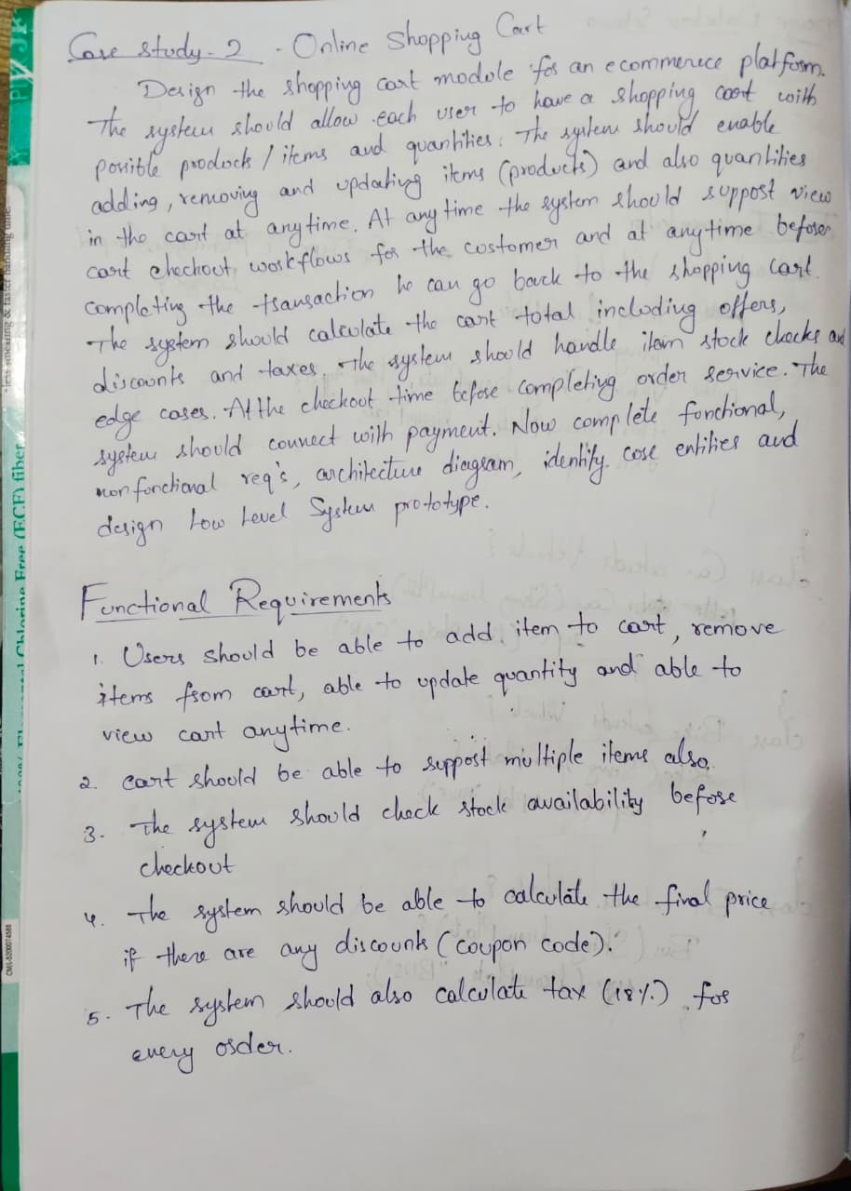
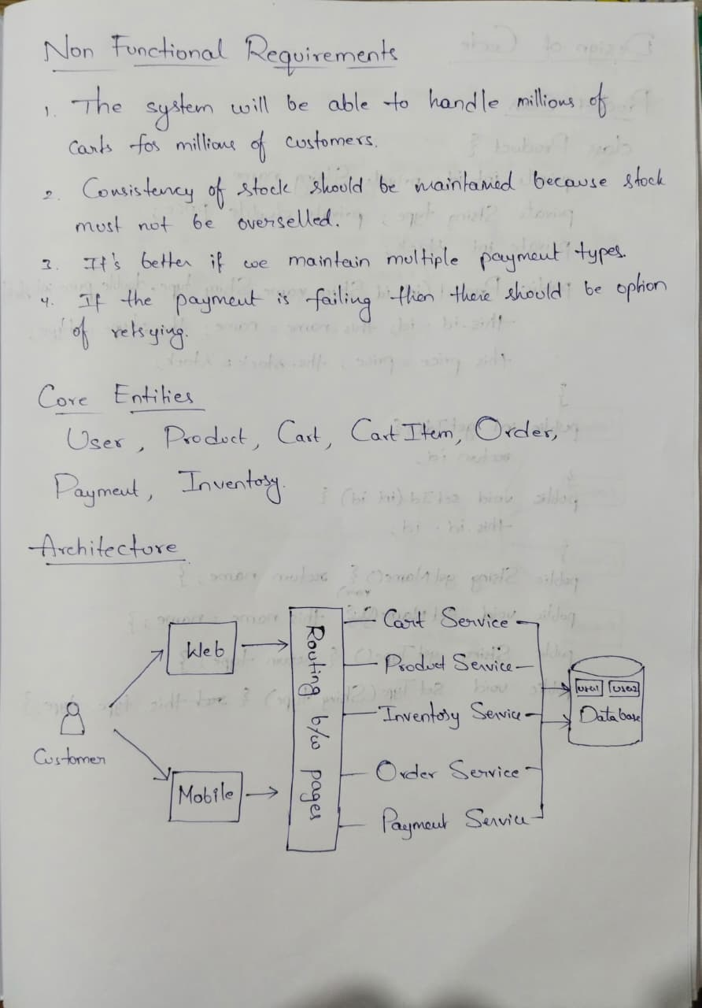
Prototype Code :
Product Class :
class Product {
private int id;
private String name;
private String type;
private double price;
private int stock;
public Product(int id, String name, String type, double price, int stock){
this.id = id;
this.name = name;
this.type = type;
this.price = price;
this.stock = stock;
}
public int getId() { return id; }
public void setId(int id) { this.id = id; }
public String getName() { return name; }
public void setName(String name) { this.name = name; }
public String getType() { return type; }
public void setType(String type) { this.type = type; }
public double getPrice() { return price; }
public void setPrice(double price) { this.price = price; }
public int getStock() { return stock; }
public void setStock(int stock) { this.stock = stock; }
}

CartItem Class :
class CartItem {
private Product product;
private int quantity;
public CartItem(Product product, int quantity) {
this.product = product;
this.quantity = quantity;
}
public Product getProduct() { return product; }
public void setProduct(Product product) { this.product = product; }
public int getQuantity() { return quantity; }
public void setQuantity(int quantity) { this.quantity = quantity; }
public double getTotalPrice() {
return product.getPrice() * quantity;
}
}
Cart Class:
import java.util.*;

class Cart {
private int userId;
private List<CartItem> items;
public Cart(int userId) {
this.userId = userId;
this.items = new ArrayList<>();
}
public int getUserId() { return userId; }
public void setUserId(int userId) { this.userId = userId; }
public List<CartItem> getItems() { return items; }
public void setItems(List<CartItem> items) { this.items = items; }
public void addItem(Product product, int quantity) {
for (CartItem item : items) {
if (item.getProduct().getId() == product.getId()) {
item.setQuantity(item.getQuantity() + quantity);
return;
}
}
items.add(new CartItem(product, quantity));
}
public void removeItem(int productId) {
items.removeIf(item -> item.getProduct().getId() == productId);
}
public void updateQuantity(int productId, int quantity) {
for (CartItem item : items) {
if (item.getProduct().getId() == productId) {
item.setQuantity(quantity);
}
}
}
public double calculateTotal() {
double total = 0;
for (CartItem item : items) {
total += item.getTotalPrice();
}
return total;
}
}

ProductSearch Class :
class ProductService {
private List<Product> products;
public ProductService(List<Product> products) {
this.products = products;
}
public List<Product> getProducts() {
return products;
}

public Product[] searchByName(String name) {
List<Product> result = new ArrayList<>();
for (Product p : products) {
if (p.getName().equalsIgnoreCase(name)) {
result.add(p);
}
}
return result.toArray(new Product[0]);
}
public Product[] searchByType(String type) {
List<Product> result = new ArrayList<>();
for (Product p : products) {
if (p.getType().equalsIgnoreCase(type)) {
result.add(p);
}
}
return result.toArray(new Product[0]);
}
public Product[] searchByNameAndType(String name, String type) {
List<Product> result = new ArrayList<>();
for (Product p : products) {
if (p.getName().equalsIgnoreCase(name) &&
p.getType().equalsIgnoreCase(type)) {
result.add(p);
}
}
return result.toArray(new Product[0]);
}
}

CheckoutService Class :
class CheckoutService {
public boolean validateStock(Cart cart) {
for (CartItem item : cart.getItems()) {
if (item.getQuantity() > item.getProduct().getStock()) {
return false;
}
}
return true;
}
public double applyDiscount(double total) {
if (total > 1000) return total * 0.9;
return total;
}
public double applyTax(double total) {
return total * 1.18;
}
public void checkout(Cart cart) {
if (!validateStock(cart)) {
System.out.println("Stock insufficient");
return;
}
double total = cart.calculateTotal();
total = applyDiscount(total);
total = applyTax(total);
Payment payment = new Payment(1, total);
payment.processPayment();
System.out.println("Payment Status: " + payment.getStatus());
}
}

